**STOCK MARKET TREND PREDICTION WITH TECHNICAL INDICATORS**

**TABLE OF CONTENTS**

Chapter 1: Introduction 3

1.1 Background of the Research 3

1.2 Research Aim and Objectives 3

1.2.1 Aim 3

1.2.2 Objectives 4

1.3 Research Question 4

1.4 Problem Statement 4

1.5 Expected Outcome 5

Chapter 2: Background 6

2.1 Introduction 6

2.2 Technical Background of the Study 6

2.3 Literature Analysis 7

2.4 Literature Gap 8

2.5 Summary 8

References 10

# Chapter 1: Introduction

## 1.1 Background of the Research

The financial forecasting advancement made by Machine Learning is the discovery of non-linear structures in voluminous market information. Technical signals Technical indicators such as Moving Average Convergence Divergence (MACD), Relative Strength Index (RSI), Bollinger Bands and volume provide measurable Price action and momentum signals in the stock market prediction (Yadav, 2025). Short-term prediction plays an essential role in algorithmic trading that encompasses more than 60% of the total global trade in equities.

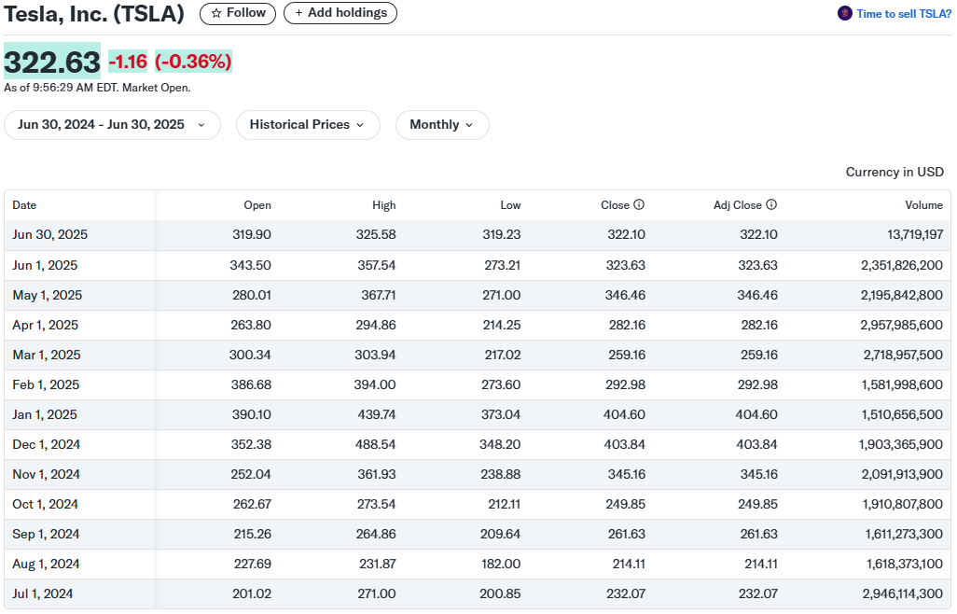

**Figure 1.1: Tesla Stock Prices**

(Source: Yahoo Finance, 2024)

Tesla Inc., a highly volatile company (daily move of ~3.5%) with 10 years of past data, is a perfect dataset when it comes to testing ML models to predict the direction of the price on the next day (Yahoo Finance, 2024).

## 1.2 Research Aim and Objectives

### 1.2.1 Aim

This study aims to come up with and test a model that uses technical indicators and machine learning to predict the course of Tesla's stock price the following day.

### 1.2.2 Objectives

* To assemble the stock price of Tesla Inc. for the previous 10 years with the Yahoo Finance API.
* To build important technical instruments: Moving Average Convergence Divergence (MACD), Relative Strength Index (RSI), Bollinger Bands and changes in price volume.
* To reframe the prediction problem as a classification task, where data points are tagged according to the direction of the next-day price.
* To train and assess machine learning models such as Random Forest, XGBoost and LSTM to find sequential patterns when possible.
* To analyse whether the model works well by assessing “precision, recall, F1-score” and checking how it does in measuring its usefulness in trading.

## 1.3 Research Question

How accurately can the price movement be predicted with the help of various machine learning algorithms, “Random Forest, XGBoost, and LSTM,” using stock price indicators such as MACD and Volume?

## 1.4 Problem Statement

Stock price forecasting stands as a challenging issue because it is characterised by volatility, noise and non-linear dynamics of the market. The classical statistical models, like the ARIMA, tend to be unable to keep up with the quickly evolving market conditions. Even though technical indicators such as MACD, RSI, and Bollinger Bands are highly popular tools in trading, there is a lack of analysis indicating the strength of such predictive tools when used in cooperation with modern machine learning models in relation to short-term forecasting. Memorably, when it comes to volatile stocks (such as Tesla), research is scarce to compare the performance of algorithms, such as Random Forest, XGBoost or LSTM. This paper fills this research gap (Imani, Beikmohammadi and Arabnia, 2025).

## 1.5 Expected Outcome

This research is expected to come up with a powerful machine learning model to classify the next-day direction (up or down) of the Tesla stock using the technical indicators successfully. LSTM is expected to perform better in capturing the temporal dependency, XGBoost, and Random Forest can give high accuracy classification because both are ensemble learning algorithms. The paper attempts to find out the effectiveness of the models in real-life financial behaviour. The performance of the models will be measured in terms of precision, recall and F1-score, which will provide some important information about the model’s feasibility to be used in algorithmic trading as well as short-term investment strategies.

# Chapter 2: Background

## 2.1 Introduction

In the fast evolution of machine learning, the effects of the latter have found their way into financial forecasting, especially in stock market prediction. The idea of combining the technical indicators with the use of smart algorithms is gaining traction among researchers and practitioners in the aim of improving their efficiency in predicting market trends. This chapter aims to review the literature that has been previously researched in this area, to identify the baseline technical definitions, to examine the previous works that have applied machine learning to financial data, as well as to spot the gaps that have not yet been filled. This chapter has given the required background and justification of the current research by critically evaluating past research, and hence the need to conduct the study.

## 2.2 Technical Background of the Study

Historical price information in the form of OHLCV data (Open, High, Low, Close, and Volume) are commonly used in the prediction of stock markets (Latif et al., 2024). Such data is used to calculate technical indicators indicating momentum, volatility and trend direction of a market. The Moving Average Convergence Divergence (MACD) is a trend-following momentum indicator commonly found among them, computed as the difference between 12-day and 26-day exponential moving averages, and indicating possible reversals on crossing the signal line. The Relative Strength Index (RSI) is one of the price momentum indicators (it quantifies a price momentum on a scale of 0100); when the RSI is higher than 70, there is likely to be a situation of overbuying; when the RSI is lower than 30, the situation of overselling can be observed (Fidelity, 2024). The movement in volatility is captured through Bollinger Bands, a set of the moving average accompanied by the upper and lower bands marked at +/- 2 standard deviations. Volume, which is often disregarded, affirms trend strength. When it comes to considerable volume in the direction of price sustains the trend, and low volume can hint at reversals.

The contemporary machine learning algorithms are utilised to take advantage of these indicators. Random Forest is another decision tree specific that combines decision trees, can deal with non-linear connections, and prevents over-fitting through the bagging method. XGBoost is a gradient boosting framework that optimises sequential tree learning through regularisation, making it the best-performing at least in tasks that involve classification (Hakkal and Lahcen, 2024). The type of recurrent neural network that is perfectly suited to sequence modeling is called LSTM (Long Short-Term Memory), and the reason is because LSTMs use a gated structure that is capable of preserving long-range dependencies, which is suitable when dealing with time-series data such as stock prices (Malashin et al., 2024).

This paper treats trend forecasting as a binary classification problem of predicting an upward or downward price movement and measures the reliability of the model elements of Precision, Recall and F1-Score, not mere accuracy.

## 2.3 Literature Analysis

Technical indicators have been the subject of the research of many scholars attempting to foresee the trend of the stock. Attesting to the high utility of technical indicators to enhance predictive accuracy, MACD, RSI, and Bollinger Bands were used in a study by Yadav, (2025) during an ANN and SVM implementation. Conversely, Zhang, Zhang and Hu (2025) detected that models based on a single technical indicator have only minimal accuracy perceived when the volatility is very high in the market, which proposed that there may be a greater performance of the hybrid approaches due to their robustness. This comparison gives a reason to keep debating the question of whether any indicators should be enough or whether there should be an addition of the data based on the macroeconomic or sentiment viewpoints.

Other areas that have been heavily investigated in machine learning are in financial prediction. Tan, Yan and Zhu (2019) demonstrated that with traditional statistical models, such as linear regression, the direction of stock price can be predicted with significantly low results, that in the case of ensemble solutions, such as the Random Forest ensemble model, it could be significantly better, as it can capture non-linear dependencies. In their study, however, a decrease in performance in high-volatility stocks was observed, which cast doubts on the topic of generalizability. Conversely, López, Arroyo and Mansilla (2024) used LSTM networks on S&P 500 data and showed their ability to outperform Random Forest in predicting S&P 500 data, with major improvements in the area of temporal relationships. Nonetheless, the complexity of LSTM, longer training time, and sensitivity to overfitting are issues with it.

The other main debate is about a modelling approach: regression vs. classification. Regression can tell the precise levels of price, but it is easier to predict with classification using categorical terms, e.g. up/down. According to Olorunnimbe and Viktor (2022), classification has a greater practical value in trading since it can be interpreted and it correlates with the steps of the trading process. Nevertheless, other researchers believe that the models of classification can miss minute price changes that are useful in arbitrage.

These contradictions point out the necessity of additional comparative analysis, particularly in terms of volatile equities.

## 2.4 Literature Gap

|  |  |  |
| --- | --- | --- |
| **Area Explored** | **What Existing Studies Have Done** | **Gap Identified** |
| Use of Technical Indicators | Applied MACD, RSI, and Bollinger Bands in prediction models using ANN or SVM | Lacked integration with advanced ML models like XGBoost or LSTM |
| Machine Learning Models for Stock Prediction | Evaluated models like Random Forest or LSTM on general or low-volatility stocks | Limited testing on high-volatility stocks such as Tesla |
| Prediction Approach | Focused on either regression (price forecasting) or binary classification individually | Few studies compared both methods using real-world indicators for direction |

**Table 2.1: Literature Gap**

(Source: Created by Author)

## 2.5 Summary

The chapter surveyed the technical background and previous work on machine learning-based stock market prediction by the use of technical indicators. It investigated the usefulness of such indicators as MACD, RSI, Bollinger Bands, and the indicators of Volumes, as well as the application of Random Forest, XGBoost, and LSTM algorithms. Literature review disclosed the inconclusive (at best) results on the accuracy of the given models in prediction and yielded controversies on the aptitude of regression versus category concepts. Noteworthy constraints were found, such as the inability to focus on unstable stocks such as Tesla and a smaller comparison between models. Such weaknesses make the purposes of the current study to test the performance of the models applicable to the real-life market data acceptable.

# 

# References

Fidelity (2024). *What is RSI? - Relative Strength Index - Fidelity*. [online] Fidelity.com. Available at: https://www.fidelity.com/learning-center/trading-investing/technical-analysis/technical-indicator-guide/RSI.

Hakkal, S. and Lahcen, A.A. (2024). XGBoost To Enhance Learner Performance Prediction. *Computers and Education: Artificial Intelligence*, 7, p.100254.

Imani, M., Beikmohammadi, A. and Arabnia, H.R. (2025). Comprehensive Analysis of Random Forest and XGBoost Performance with SMOTE, ADASYN, and GNUS Under Varying Imbalance Levels. *Technologies*, 13(3), p.88.

Latif, S., Javaid, N., Aslam, F., Abdulaziz Aldegheishem, Nabil Alrajeh and Safdar Hussain Bouk (2024). Enhanced Prediction of Stock Markets using a Novel Deep Learning Model PLSTM-TAL in Urbanized Smart Cities. *Heliyon*, pp.e27747–e27747.

López, A.C., Arroyo, J. and Mansilla, J.E. (2024). S&P 500 stock selection using machine learning classifiers: A look into the changing role of factors. *Research in international business and finance*, pp.102336–102336.

Malashin, I., Tynchenko, V., Gantimurov, A., Nelyub, V. and Borodulin, A. (2024). Applications of Long Short-Term Memory (LSTM) Networks in Polymeric Sciences: A Review. *Polymers*, 16(18), pp.2607–2607.

Olorunnimbe, K. and Viktor, H. (2022). Deep learning in the stock market—a systematic survey of practice, backtesting, and applications. *Artificial Intelligence Review*.

Tan, Z., Yan, Z. and Zhu, G. (2019). Stock selection with random forest: An exploitation of excess return in the Chinese stock market. *Heliyon*, 5(8), p.e02310.

Yadav, P. (2025). Technical Analysis Vs Fundamental Analysis: A Comparative Study of Bollinger Bands, RSI and MACD Against Fundamental Factors in Commodity Trading. *Journal of Marketing & Social Research*, 2, pp.323–329.

Yahoo Finance (2024). *Tesla, Inc. (TSLA) Stock Historical Prices & Data - Yahoo Finance*. [online] Yahoo Finance. Available at: https://finance.yahoo.com/quote/TSLA/history/?frequency=1mo.

Zhang, Y., Zhang, T. and Hu, J. (2025). Forecasting Stock Market Volatility Using CNN-BiLSTM-Attention Model with Mixed-Frequency Data. *Mathematics*, 13(11), p.1889.